
MeltonCraft™ Tapered Column
Cover Installation Instructions

Warning: the precision machined edges of MeltonCraft CPVC column components can be extremely sharp. Use of appropriate personal protection equipment is required: wear gloves when handling the product, wear a dust mask when cutting the product, and always wear eye protection.

Use of polyurethane adhesive, such as Gorilla Glue®, Loctite® PL Premium® Adhesive, Christy’s™ Clear PVC Pipe Cement (or other clear PVC cement), or similar products is recommended. Always observe adhesive manufacturer’s instructions.

Assembly is easiest with pneumatic or electric pin-nailers. These should recess the head of the pin nails far enough that only a minor touch-up is necessary (touch-up with caulk prior to painting.)

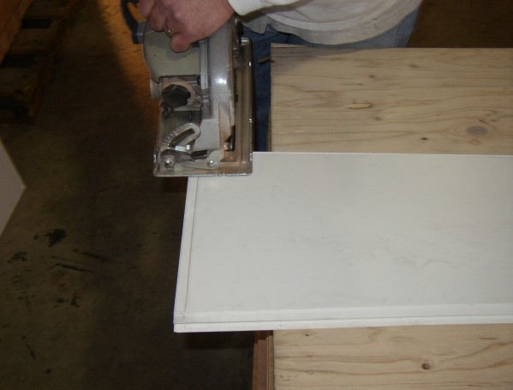
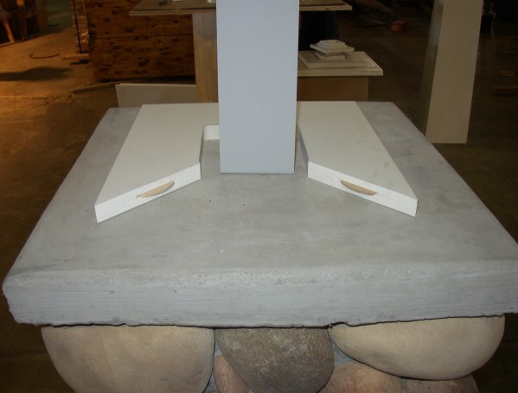
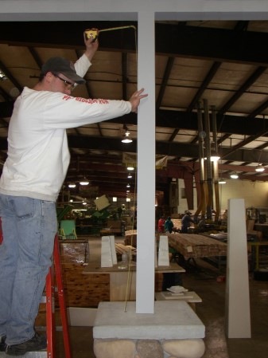

1) Measure overall opening from
floor to beam or soffit (must have structural pressure-treated post or lally column for load support.)

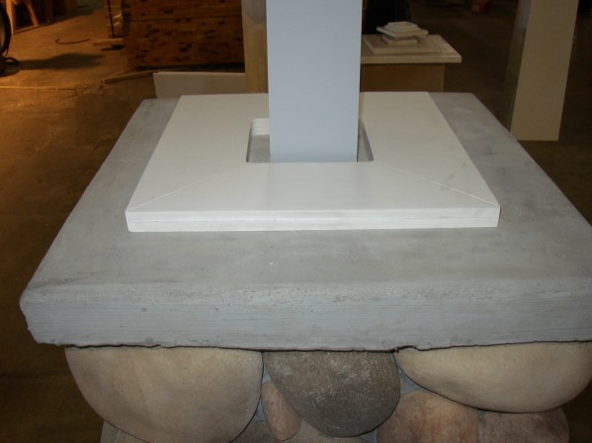
4) Glue base platform pieces using biscuits (supplied). Center and attach base to floor/pedestal with appropri- ate fasteners.

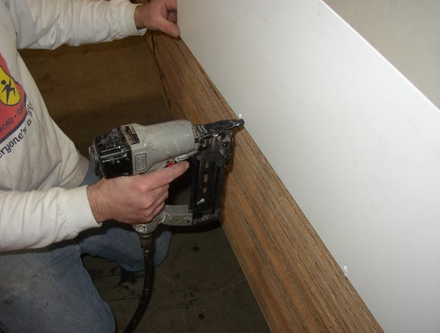
7) Finish nail three panels together.
2) Trim shaft pieces to 2¼" shorter than opening—2" for cap/base, ¼" for expansion (¼" if not using cap and base—each part is 1" thick.) Always trim from bottom ONLY- top is marked.
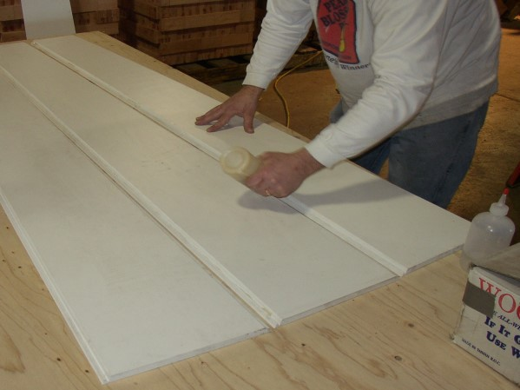
5) Lay 3 panels flat and apply adhesive to center joints. (Poly- urethane glue is recommended. Fol- low manufacturer's instructions.)

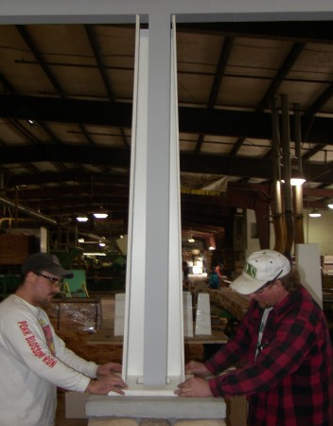
8) Slide assembled 3-sided column around support (on top of base plat- form).
3) Slide ¾ cut base platform section around post.

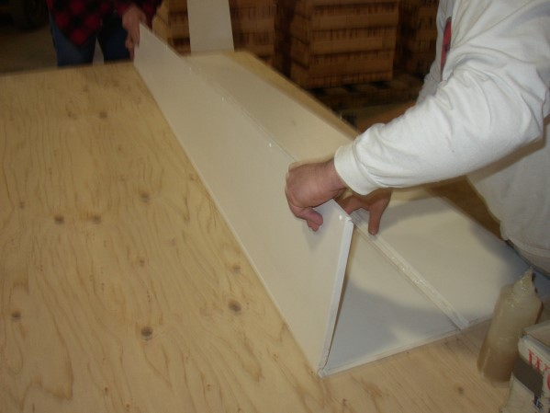
6) Assemble three panels, using miter joints.

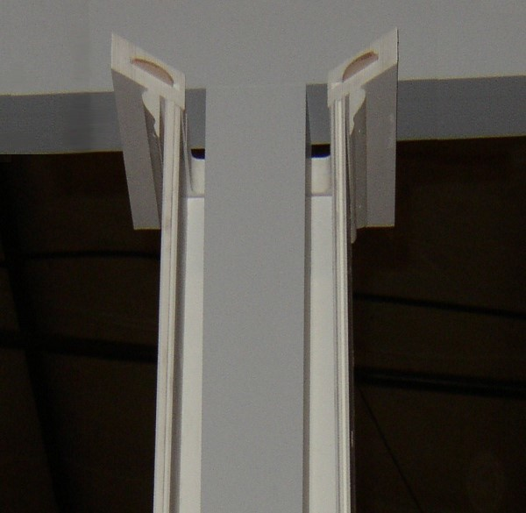
- Slide ¾ cap platform section into place on top of column
panels.*

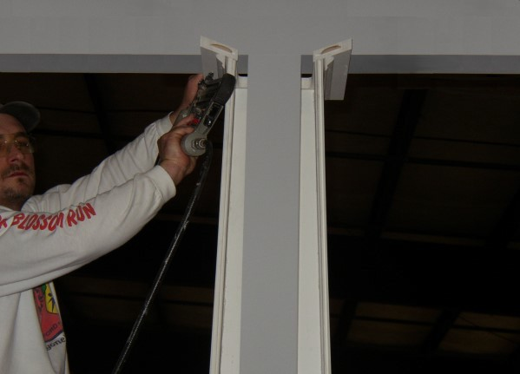

- Raise 3/4 cap platform section to beam/soffit, center, and attach. There should be 1/4" space for expansion between column and cap platform.
- Apply adhesive to final panel. 12) Assemble final panel to col-
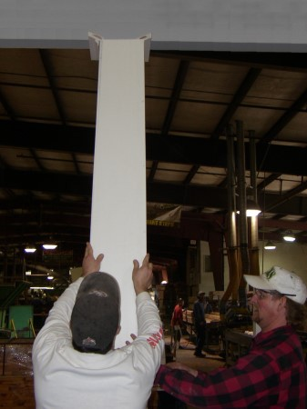
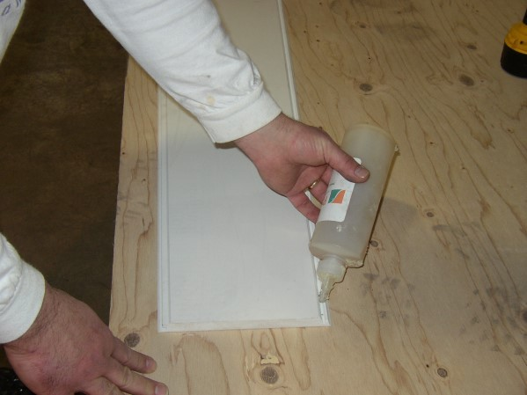
umn using miter joint. Nail panel to secure in place.

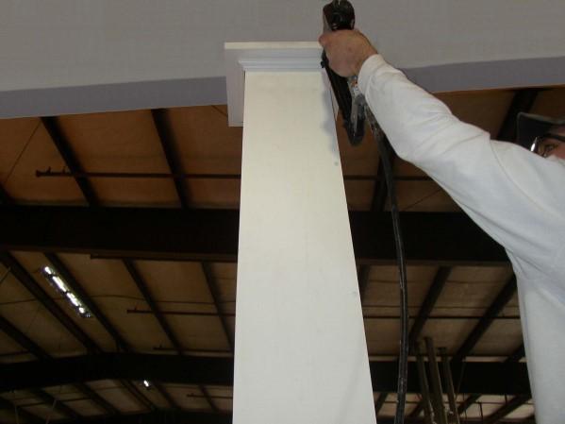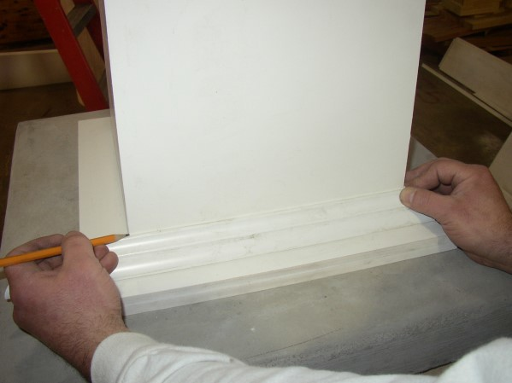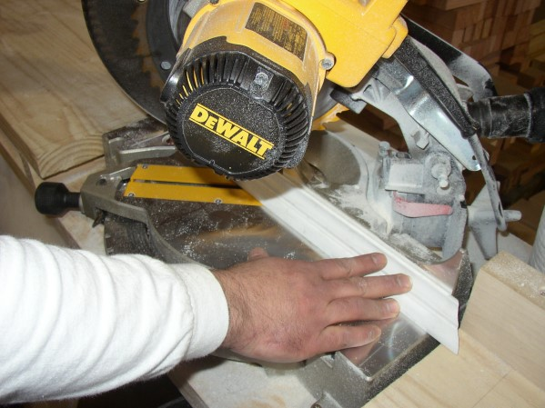

13) Apply glue to final ¼ cap piece and biscuits and slide into place. Pin nail cap moldings to top of column.*

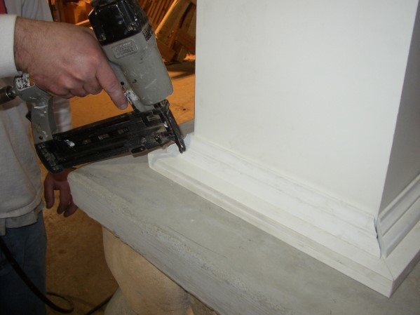
16) Center trim moldings around shaft. Apply adhesive to base trim moldings and pin-nail into base platform. (Do not attach to shaft.) There should be about a 1/16” gap around shaft.
14) Use column shaft to check length of base trim molding. If trim is too long, mark cut lines for miters. Moldings should be about 1/8” long- er than the width of the column.**
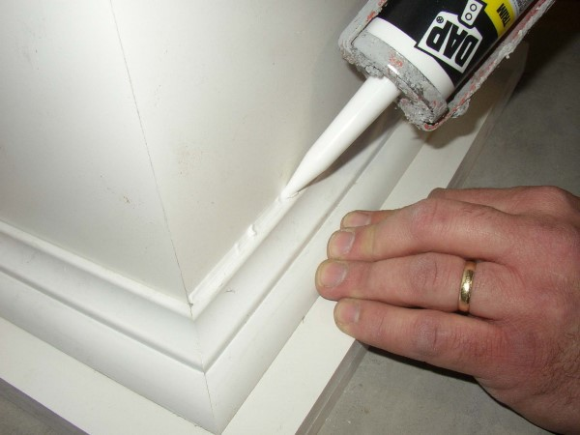
17) Caulk using latex caulking compound to fill any gaps and nail or screw holes.
15) If base trim moldings are too long, use miter saw to cut base trim pieces to fit around bottom of col- umn.**

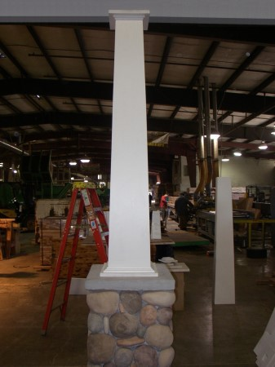
- Clean surface of column with cleaner recommended by the paint manufacturer. Paint with 2 coats of acrylic latex paint.

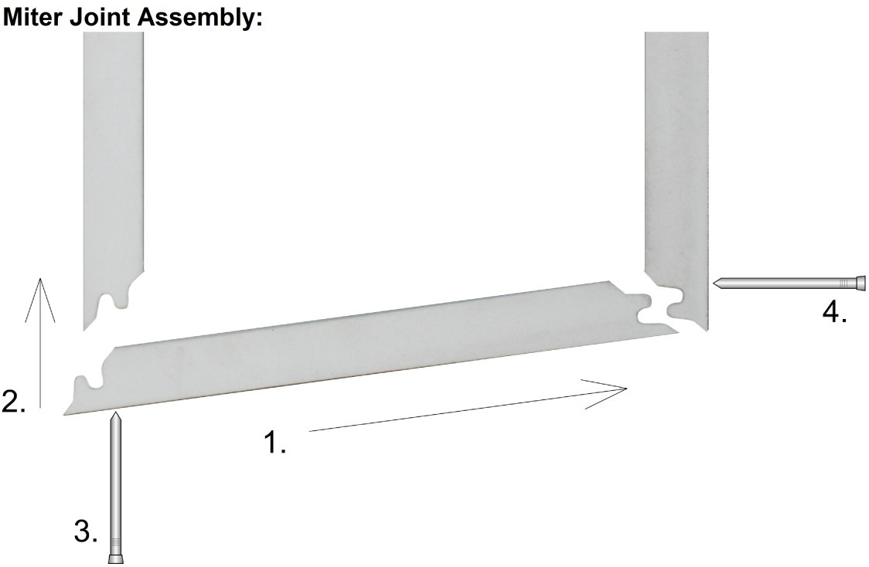
Please note the correct assembly of the miter joint shown at the left. Nails MUST be installed only in the edges shown (3 and 4). Installing on the other edges may result in open seams.
  - Glue both joint edges; slide first joint together
  - Push second joint closed
  - Nail this joint first
  - Nail this joint second
Notes:
Panels are marked “TOP” — trim from the bottom only. Cap and base pieces are also marked as “CAP or “BASE” Only use non-corrosive fasteners — galvanized, stainless steel, etc.
Always follow glue and paint manufacturer’s instructions.
*Column must not be allowed to collect water, debris, etc. If the top of the column extends beyond the soffit/beam, the cap must be flashed with lead, copper, aluminum, etc. to prevent entry of water or foreign materials.

